There has been lots of talk about safety in the professional peloton recently. The basis of the discussion stems from an association with speed and crashes. The argument can be summarized thusly:
- The peloton is faster than ever
- Riders are crashing more frequently/severely
- More frequent/sever crashes are due to the increased speeds
  - Therefore, slowing the peloton down will reduce the number/severity of crashes.
The UCI has (or will be) implementing a number of new measures that they say will improve safety, mainly by slowing riders down. Most of the virtual ink spilled about the measures have been less-than-complementary towards the efforts, suggesting that, at best, they are ill-conceived half-measures that won’t accomplish anything, and at worst, they are distractions from the real safety issues present in professional cycling and will cause other unforeseen negative issues and maybe even more crashes.
The initial argument may, on its surface, make sense, but it relies on some assumptions. If we assume that the peloton is faster, and that this leads to more crashes, then the conclusion that slowing riders down will improve safety. There are three basic questions that need to be answered before reaching the final conclusion:
- Is the peloton actually faster?
- Are riders crashing more frequently?
- If those are both true, are they related?
There is plenty of data out there on the professional peloton. Let’s see what we can find out.

Is the peloton actually faster?
On its surface, this seems like an easy question to answer: look at the average speeds of races over the years, and if it goes up, then the peloton is faster. For simplicity, let’s look just at the men’s Tour de France. We could look at all World Tour races, but focusing on just the Tour has some advantages:
- It happens at the same time every year (except 2020)
- The best riders are presumably peaking for the Tour, meaning they’re likely to be at their fastest
- Each modern Tour has 21 stages of varied terrain, representing what is seen in most races on the calendar
We’re also limiting this to just the men’s peloton. The women’s peloton shows some interesting trends based on unique factors, such as the increase in professionalization of the sport, and merits its own analysis.

(Source: Procyclingstats.com)
Since the beginning of the Tour, there is an obvious upwards trend in speed. The reasons for this are numerous – changes in the nature of the race, team tactics, improvements in technology, nutrition, pharmaceutical enhancements, etc. There does seem to be a flattening of the trend starting around 2000, so let’s have a closer look.

(Source: Procyclingstats)
Things are less clear when looking at this sliver of time. 2021 to 2024 are some of the fastest tours in history, peaking in 2022, but they’re not outliers. Take a look at the y-axis. The range of values isn’t exactly huge. The slowest TdF on this chart was in 2007 at 38.98 kph, and the fastest was 2022 at 42.03 kph. That’s just over 3 kph (or 1.9 mph) difference. According to Sheldon Brown’s gear calculator, that’s about the difference between spinning at 90 rpm in a 52x14 and a 52x15. Since 1998, the difference between the slowest and fastest TdF is about 7%.
Does a 7% difference in speed matter? Is the difference of a single sprocket a true sign that the peloton is faster than ever? On the surface, it’s easy to say yes, but once you dig down a little, the answer gets more complicated. There are some ways of answering this question, but there remains a more fundamental issue: what do the individual data points actually mean? If we’re talking about the average speed of the TdF, all we know is that the riders (actually, only the winner; everyone else was going slightly slower) rode at said average speed. It doesn’t tell us anything about how they rode; nothing about how slowly they crawled up the mountains, or how fast the sprints were at the end of the flat stages, or if the breakaway managed to stay away. It says nothing about how stages were raced, how many mountains were climbed, or how many kilometers of time trials were included. All we know is, at the end of 21 stages, the peloton covered 3500-ish kms of racing in 90-ish hours. To make any meaningful conclusions about a 7% difference in those speeds over such a large timespan that gets broken up in different ways every year is difficult.
What’s more is that the TdF itself varies by more than 7%. If we look at total distance, the TdF varies by about 12% during that timeframe. If we look at meters of climbing, it varies by over 30%! (If you take out 2006, which was an outlier and had a much lower amount of climbing, the difference is 20%).

(Source: Procyclingstats)

A reasonable hypothesis would be to relate both course distance and total elevation to overall average speed. As distance goes up, speed goes down; same with elevation and speed.

You have to squint quite a bit and tilt your head far to the side to see a pattern in those values, and the statistics agree. Distance is very weakly correlated with speed, and elevation is not correlated at all. The R² value, which is generally interpreted as the percentage of how much one variable predicts another, is 0.05 for distance and 0.002 for elevation, meaning that 5% of the difference in speed can be attributed to distance, and 0.2% can be attributed to elevation.
Based on these results, I think it’s fair to say that looking at the average speed of the TdF tells us very little about the actual speed that the peloton is moving. It is too broad a measure and tells us very little about how that average came to be.

What does “faster” mean?
One of the problems with just looking at the TdF average is that it does not account for any changes in speed during the actual race. It tells us how much time the peloton covered the entirety of the 21 stages but says nothing about how fast the peloton is going at any given moment. If we had recordings of every stage, we could see that, but unfortunately for us, the existence of Strava only covers a small portion of our timeline, and public postings of stage results from pros an even smaller proportion. So how can we get a more granular view of the peloton’s actual speed?
Lucky for us, sites like procyclingstats.com have records for each stage, including the distance and winning time. From that, we can get the average speed for each individual stage. As stages are generally between 3 and 6 hours, this still doesn’t capture every change in speed, but we’re getting more granular than 90+ hours. Looking at individual stages gives a better idea of the speed that the peloton is going at a particular time better than the overall average. It’s not perfect, but it will do for our case. By averaging the speed of the stages, we’re also getting closer to the actual speed of the peloton. An overall TdF average naturally weights the calculation towards longer stages – the more kms covered, the bigger influence that stage has in the overall average. Removing that weighting moves us closer to looking at the actual speed that the peloton is moving, which is what we’re really interested in for this particular analysis.
Another advantage of looking at the individual stages is that we get a better idea of the variation from day to day. Sprint stages are going to be faster, and mountain stages are going to be slower. We can also exclude anything that isn’t a mass start road stage from our measures, such as any flavor of time trial. If we’re concerned about the speed of the peloton, it makes sense to exclude any stages where there is no peloton.

This chart tells a similar story to the overall average speed, but not quite the same. Here, the difference between slowest (2015) and fastest (2022) is even smaller at 6%. The question remains: is that a significant difference?
Using the stage average speed, we get one more statistic to use to help determine if the speed difference is real or not: the variability of the stages that go into each yearly average. Each data point on the chart above is the average of 18-20 stages (depending on the year).

If we plot a histogram which shows the overall distribution of speeds over our time frame, this shows us the variability of stage speed. There is a wide spread of speeds, depending on the type of stage. To quantify the spread of speeds, we can calculate the variance for each year. Once we have the average speed and variance, we can then compare years to see if they are in fact different. We’re not just comparing the averages, we’re including the whole distribution of speeds. To make such comparisons, we use statistical tests that compare distributions and tell us what the probability is that they are different due to chance versus truly being different. There is a whole heap of tests that can be used, but for this, we can use a t-test, one of the most basic. T-tests are generally covered in the beginning of the second semester of stats classes. Averages, ranges, and the like all describe data: they’re called descriptive statistics. T-tests are one of the simplest test in the branch of inferential statistics, which involves using sample data to make inferences or draw conclusions. T-tests compare two distributions and assign a probability that they are in fact different. In most behavioural studies, we want to see that the probability is less than 1 in 20, or 5%, that the difference is due to chance in order to say the differences are real. We look at the p-value that comes out of the test: if the p-value is less than 0.05, then we consider the difference to be statistically significant. Other fields, such as particle physics, may use a lower threshold as they expect to see less variation, but considering we’re looking at the behaviour of a large group of riders, then I think we’re justified in using 0.05.
The most logical place to start would be to compare the slowest year with the fastest year. If those two years aren’t different, then everything in between wouldn’t be considered different. For stage averages, 2015 is the slowest year at 40.08 kph, while 2022 remains the fastest at 42.42 kph. When we perform the t-test between the years, we get a p-value equal to 0.1158, well above our threshold of 0.05, so the average difference is not significant. You may look at that and think it’s only an 11% chance, so isn’t that still pretty good? One of my stats professors once said that significance is like being pregnant – you can’t be a little significant, either it’s significant or it’s not.
It's important to note the limitations of our analysis. Using individual stages, we’re still only looking at an average over a few hours at a time, but that’s probably the best data we’re going to get. There’s also so many factors that can’t be controlled. We’re kind of comparing apples to apples – it’s more like we’re comparing Fijis to Granny Smiths where there are some similarities but still plenty of inherent differences. If we put the modern peloton and the peloton from 20 years ago in exactly the same situation, we might be able to make comparisons, but that is entirely unrealistic. We can’t run this as an experiment, so this observational data is likely as good as we’re going to get.
Having said that, what the data can tell us is that the TdF peloton has not varied in speed in a significant way over the last 20 or so years. Why might this be? This is just speculation, but my theory has to do with the overlap between what I call the Blood Doping Era and the Marginal Gains Era. I’m willing to assume (and this is a big assumption) that Operation Puerto in 2006 signaled the beginning of the wane of blood doping’s influence on the sport. Obviously, it didn’t go away immediately after that, but if you plotted the influence of blood doping on the sport over time, it would likely go up in the early 90’s and start declining after 2006. Shortly following that was the increased look at optimization of everything from equipment to nutrition, with Team Sky being the first to publicly embrace the Marginal Gains philosophy, becoming the dominant influence in 2012. The dovetailing of these two eras may account for the small variations in speed since 1998. Other interpretations exist as well, some more cynical than others: I’ll leave those as an exercise for the reader. The current narrative that the peloton is faster than ever is both true and somewhat misleading. The peloton is in fact at the peak of speed, but it’s been there since at least 1998. The sudden crop of concerns about the danger of said speed seem manufactured. If we are so concerned about the speed, why weren’t the alarm bells ringing 20 years ago?

Is the peloton more dangerous now?
I think I’ve done a reasonable job in dispelling the idea that the peloton has suddenly sped up over the last few years. While doing so effectively invalidates the entirety of the original premise, it’s still worth looking at the second statement, that riders are crashing more frequently and severely. If you go to procyclingstats.com, they have a whole page related to injuries.
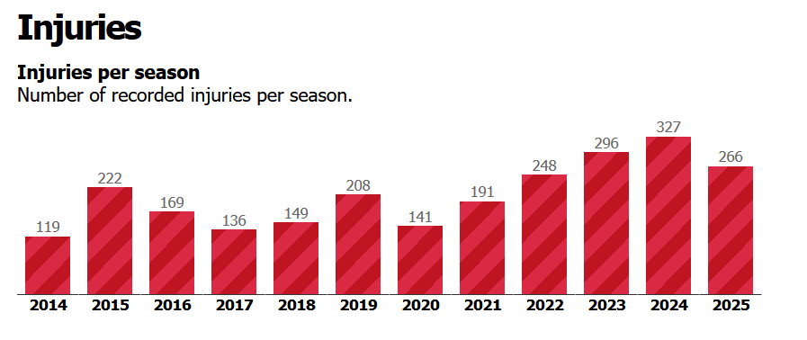
(Source: https://www.procyclingstats.com/statistics/riders/injuries)
Looking at the chart, we run into similar problems that we did with the speed data, plus a few additional ones. Firstly, it looks like there is an upward trend, with 2022-2024 having more injuries than any previous year, and 2025 looking even worse as it’s only about 2/3 over. There is still quite a bit of variability throughout the years, with a range from 119 to 327. These numbers average out to 206 injuries per year. With this limited set of data, it is difficult to determine any trends.
Secondly, there is the question of what this data actually means. Procyclingstats.com has a list of injuries by frequency:
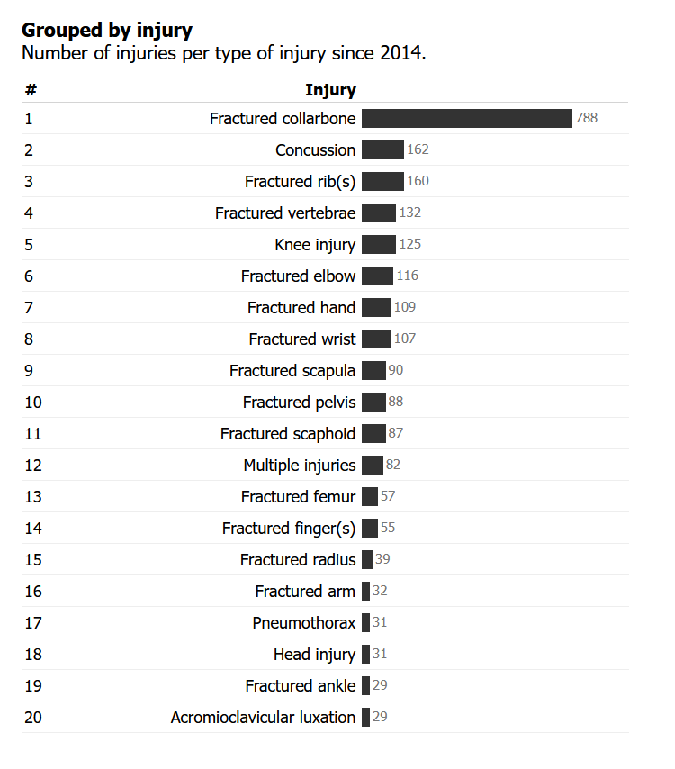
There are some technical questions here, such as why is fractured scaphoid (a bone in the wrist) separate from fractured wrist, and are they double-counted? Same with multiple injuries – are the individual injuries counted elsewhere? Are these limited to injuries from racing, or does this list include training injuries? For example, John Degenkolb’s rider page lists two injuries, one from a crash at the Tour of Flanders in 2025, and one in training in 2016. The 2025 injury lists 3 separate injuries, while the 2016 injury is listed as “multiple injuries.” Fundamentally, why is the list capped at these injuries? Basically, we need to define “injury.” It seems as though the definition is limited to those that result in time away from training or racing. Even with that definition, it seems limited, as I think we could all think of other injuries that would lead to time off the bike. Get bad enough road rash, and you’re probably going to take some time off.
Sidebar: There appears to be a UCI Incident Tracker, developed by researchers at the University of Ghent. I have contacted the principal investigators with questions about the tracker and database but have had no response at the time of writing.
There is a much more fundamental question about this data, namely where does it come from? Teams may put out reports or social media posts on injuries, and races usually have a medical report to list riders who needed some sort of medical attention during the race. I can’t imagine that the reporting is consistent across teams and races. With the increased presence of teams on social media, I think one could make a reasonable hypothesis that a contributing factor to the increase of injuries is more frequent reporting by teams or individual riders.
With the questions about the providence of the injury data, where else could we go to see if being in the peloton is, in fact, more dangerous than ever? For similar reasons as when looking at speed, I would suggest looking at the Tour de France as a relatively repeatable microcosm of professional cycling. The results pages of each stage list the riders who Did Not Finish (DNF) or Did Not Start (DNS). To take a birds-eye view, we can look at the percentage of riders who finished the Tour 21 days after starting.

If we ignore the obvious outlier that was the Festina Affair year of 1998, the average percentage of riders finishing the TdF is 78%. Looking for trends, the 1990s look to be quite a bit lower (again ignoring 1998) than the current 5-10 years. In fact, since 2015, only one year (2021) had a below-average percentage of finishers, and that year was 77%.
One element of the Tour that has changed since 1990 is the number of starters. The number of riders per team has decreased, so from 1990 to 2017, the number of starters was anywhere between 180-198. From 2018 onward, only one year had more than 180 starters. One hypothesis could be that the percentage of finishers is negatively correlated with the number of starters, meaning that more starters would lead to a lower percentage of finishers because smaller peloton is safer. The numbers, however, do not support this.

There is no obvious trend here. In fact, the correlation between the number of starters and percentage of finishers is not significant, meaning that it doesn’t really exist in any meaningful way.
It is worth noting that the number of finishers of the TdF is in no ways a perfect metric of safety. Firstly, these numbers include riders leaving the Tour before the finish line in Paris (or Nice) for any reason, not just due to injury. This includes (but not limited to) OTL (over time limit), disqualification, illness, doping positives, personal reasons, or any other reason why a rider might not start or would climb into a car mid-stage for mysterious reasons. By associating the percentage of finishers to safety, we are making a major assumption that the other reasons for leaving the race hold fairly steady throughout the years. Any change in finishers is then assumed to be due to injuries sustained through racing. Without going through reports of every stage, this can’t be easily quantified. I would assume that there are cabinets full of post-stage written reports back at UCI headquarters, but that’s not exactly a usable format for us, or really anyone.

Speed vs. danger – is there a correlation?
We’ve shown that the speed of the peloton does not seem to be significantly faster than it has been, at least in the last 25 or so years, and that the number of abandons at the TdF has also been pretty steady, if not trending positively. While regarding the limitations of the data and analysis, I think we have pretty thoroughly refuted the first two statements in our opening premise. Considering the statement correlating speed with danger relies on the first two being true, we’ve also effectively refuted that as well. Just for fun, let’s see if the average TdF speed is related to the percentage of finishers.

There is a real correlation between the percent of finishers and the average TdF speed; however, it is a positive correlation, meaning that as speed increases, the percent of finishers increase as well. This is not an immensely strong correlation – R² is 0.15, meaning this only explains 15% of the variation, but it is real (if we remove outlier 1998, R² goes up to 0.20). This result flies directly in the face of the conclusion of the initial premise – according to this analysis in isolation, if we want to decrease crashes, we should increase the speed of the peloton.
To counter this statement that seems absurd on its face, let’s dive a little deeper by looking at individual stages. For this, we can get the number of DNFs and DNSs directly, thereby avoiding including any DQs or OTLs. We still don’t know why any rider DNF’d or DNS’d, but we’ll keep the assumption that those leaving the race for reasons other than crash injury remained constant. We can’t necessarily use just the number of DNFs on a stage to indicate who abandoned due to crashes on the stage. Many riders will soldier on and finish a stage after a crash (whether or not they should) but then not start the next stage. Let’s define the number of abandons on a stage to be the number of DNFs for that stage, plus the number of DNSs for the following stage. For example, Stage 17 of the 2022 TdF had 1 rider DNF, and 3 riders DNS the following stage. For Stage 17, the number of abandons is 4. This again misses some cases, such as João Almeida abandoning two stages after his injury this year, but without scouring every race report, this is probably the best we’re going to do.
Looking at abandons, there is an average of 1.51 abandons per stage in the TdF from 2020 to 2024. Of the 97 road race stages, 35 (36%) had 0 abandons, with a max of 8 (Stage 11, 2021, and Stage 14, 2023). Looking a plot of stage speed and abandons, no obvious pattern emerges.

Since an abandon is a discrete event, we can use a regression model specifically for count data, called a Poisson model. I won’t go into the details, but basically, the model looks to see if an increase in speed predicts the number of abandons. As you can probably tell from the chart, the model is not significant, so speed does not predict the number of abandons.
Where does this lead us?
I think these results are a good indication about how messy the data is. We’re talking about 180-200 riders riding 3500 kms in a variety of circumstances. The data is never going to tell a clean story. We can’t run an experiment to look at speed and accidents: we have to rely on observational data. I think it is important to not just look at the surface numbers and assume they are showing everything that is going on. Some level of deeper statistical analysis can help to shed light on some things, but the fact that we’re looking at group behaviours will always produce lots of noise and limit how deep we can confidently go with any sort of analysis. Having said that, it is important to question any sort of data being presented, especially when broad-sweeping conclusions are presented based on said data, leading to actions that may or may not be warranted or accomplish their intended purpose.
Much of the debate about the measures introduced to reduce the speed of the peloton have hinged on one of two arguments: one, that the measures won’t actually decrease the speed, and two, that the measures will lead to more problems than they will solve, possibly making the safety problems worse. This analysis shows that there is at least one more argument against the measures, in that a marginal decrease in speed won’t actually lead to safer riding. Dan Bigham provided some proposals that would actually increase safety in his presentation at the Cycling Science conference recently. His proposals may be more difficult to implement than measuring handlebar width, but would likely be more effective. If the UCI is serious about increasing safety, they could find worse places to start than his proposals.
I have a general rule of thumb that I use whenever a large entity (government, sporting organisation, corporation, etc.) acts on an issue: the lower down the pecking order the rule directly affects and forces to change, the more likely the action is purely for show and/or for completely different, undisclosed reasons. Considering the current proposals impose the changes on the riders, I think the UCI has shown just how serious they are about the issue.

